Company name:

Brand

**Fater Electronic**

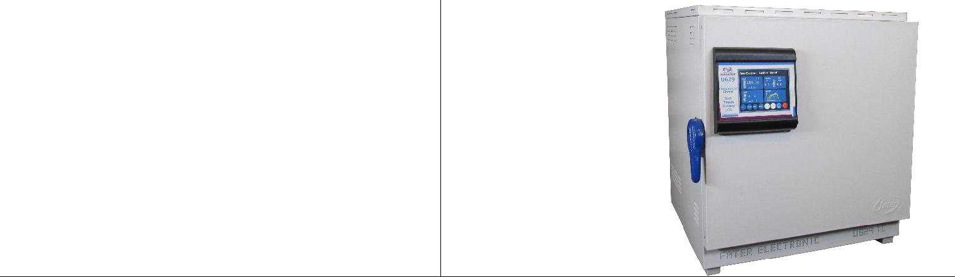

|  |  |  |
| --- | --- | --- |
| Product Specifications: **B629 TC** | Product photo: |  |
|  |  |

**55 liter incubator**

**10 STEP programmable setting**

* **single step include data logger (available sizes from 55L up to 2000L)**

production capacity**:**

offer price in China ($):

**US$ 880**

|  |  |  |  |  |  |  |  |  |  |  |
| --- | --- | --- | --- | --- | --- | --- | --- | --- | --- | --- |
|  | Maximum order/Minimum delivery time (EX: one ton/one month or 1000/year or ….): | | | | | | | |  |  |
|  | **200 pcs /** | **45 days** | |  |  |  |  |  |  |  |
|  | MSDS OR Technical data sheet: | | |  |  |  |  |  |  |  |
|  |  |  |  |  |  |  |  |  |  |  |
|  |  |  | Technical | MODEL: | |  | MODEL: | MODEL: | MODEL: |  |
|  |  |  | Specifications | B629 TC | |  | B630 TC | B631 TC | B632TC |  |
|  | Test Volume |  | Liters | 55 |  |  | 65 | 120 | 200 |  |
|  | Interior |  | mm | 330×420×400 | |  | 460×330×400 | 330×700×500 | 400×800×600 |  |
|  | Dimension |  |  |  |  |  |  |  |  |  |
|  | Exterior |  | mm | 450×560×500 | |  | 450×600×500 | 450×800×600 | 500×900×700 |  |
|  | Dimension |  |  |  |  |  |  |  |  |  |
|  | Shelf |  | Pcs | 1 |  |  | 1 | 2 | 3 |  |
|  | Touch Display |  | ``5.7 | Color LCD | |  | Color LCD | Color LCD | Color LCD |  |
|  | Temperature |  | C | ambient up to | |  | ambient up to | ambient up to | ambient up to |  |
|  | Range |  |  | +60 C ± 0.1 | |  | +60 C ± 0.1 | +60 C ± 0.1 | +60 C ± 0.1 |  |
|  | power |  | W | 600 |  |  | 800 | 1000 | 1000 |  |
|  | Electrical |  | V/Hz | 50/220 |  |  | 50/220 | 50/220 | 50/220 |  |
|  | Connection |  |  |  |  |  |  |  |  |  |
|  | contact person: |  | Ali Arghavan |  | Company contact: | | |  |  |  |
|  | Email: head@fater.ir | | |  | Website: www.fater.ir (www.fater-electronic.com) | | | | |  |
|  | Tell: +98- 9121272405 | | |  | Email: head@fater.ir | | |  |  |  |
|  | Address**: Tehran-Iran** | | |  | Tell: +98 -21 88552340-42 | | | |  |  |
|  |  |  |  |  | Fax: | | +98 – 21 88552305 | |  |  |
|  |  |  |  |  | Address: No.14, 18th St., Vozara Ave., Tehran-Iran | | | | |  |



Company name:

|  |  |  |
| --- | --- | --- |
|  | Brand | |
| **Fater Electronic** |  |  |
|  |  |  |
| Product Specifications: |  | Product photo: |
| **620G** |  |  |
| , |  |  |
| . |  |  |
| . |  |  |
| , | : |  |
|  |  |  |

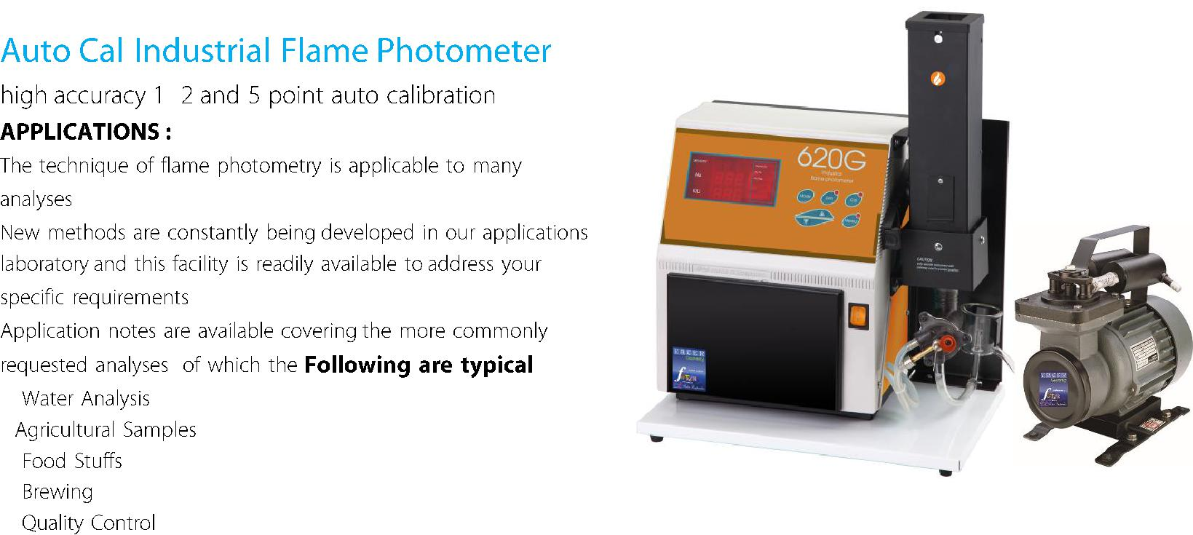

production capacity**:**

offer price in China ($):

**US$ 3,450**

Maximum order/Minimum delivery time (EX: one ton/one month or 1000/year or ….):

**20 pcs /** **45 days**

|  |  |  |  |  |  |  |
| --- | --- | --- | --- | --- | --- | --- |
|  | : |  |  | % | |  |
|  |  |  |  | : | |  |
|  |  | . |  |  |  |  |
|  |  |  |  |  |  |  |
|  | : |  |  | : | |  |
|  | . % |  |  | % . . | |  |
|  | , | , , |  | : | |  |
|  |  |  | , |  |  |  |
|  | . |  |  |  |  |  |
|  |  |  |  |  |  |  |
|  | contact person: | Ali Arghavan |  |  | Company contact: |  |
|  | Email: head@fater.ir | |  |  | Website: www.fater.ir (www.fater-electronic.com) |  |
|  | Tell: +98- 9121272405 | |  |  | Email: head@fater.ir |  |
|  | Address**: Tehran-Iran** | |  |  | Tell: +98 -21 88552340-42 |  |
|  |  |  |  |  | Fax: +98 – 21 88552305 |  |
|  |  |  |  |  | Address: No.14, 18th St., Vozara Ave., Tehran-Iran |  |

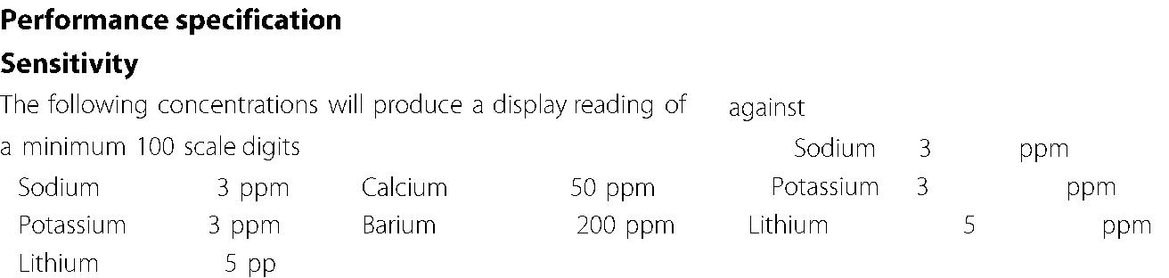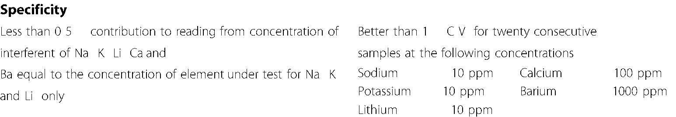

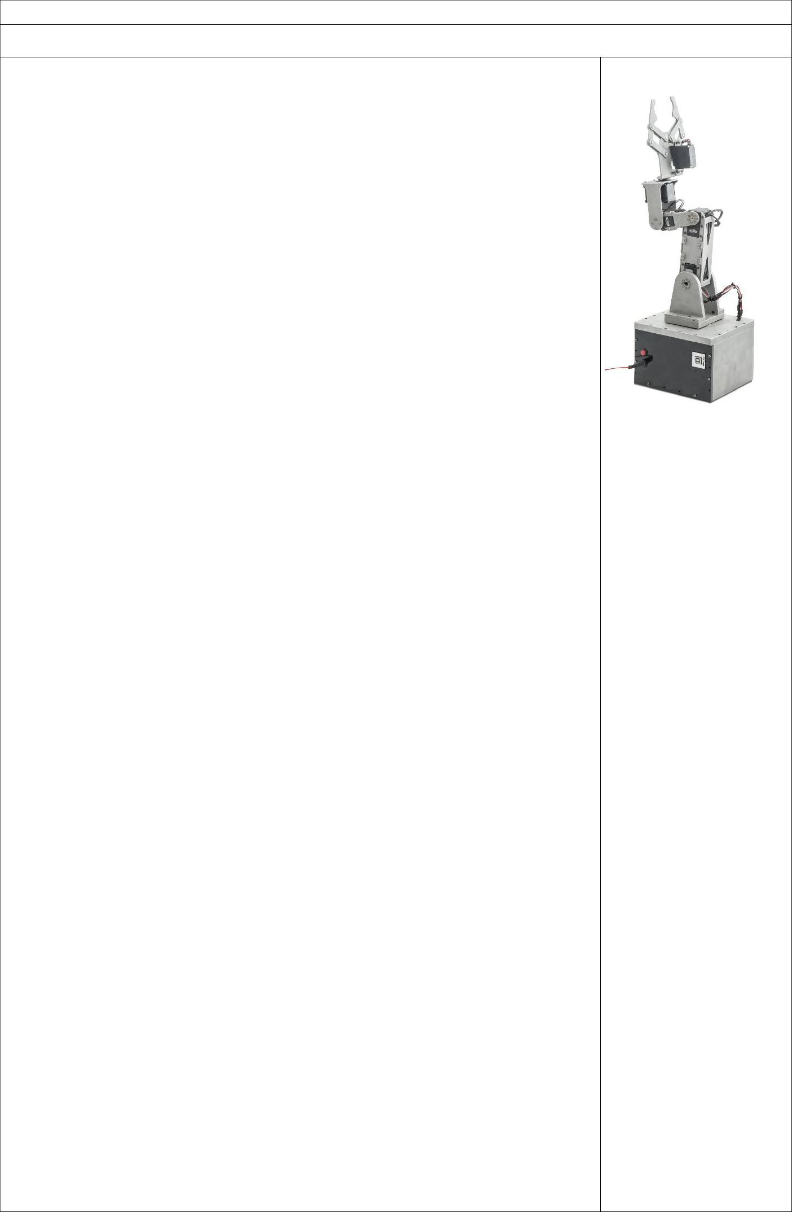Company name: Qeshmvoltage

Brand: **Qeshmvoltage**

|  |  |
| --- | --- |
| Product Specifications: | Product photo: |

* Simple coding
* The ability of cooperation with other QVR-KIN-DX51 robots automatically & real time in different ways (more than 5 robots)
* Doing the same thing the same time
* Manipulating one robot & the other one or ones would follow the path real time & Simultaneously
* Using MATLAB & LABVIEW
* The ability of observing the robot or robots & the computer simulation Simultaneously
* Wireless connection with computer & other robots
* Using virtual reality
* 5 degrees of freedom
* The ability to change the way the joints move just with a simple setting change in computer (full explanation in manual)
* J0 rotation space is almost 270 degrees
* Work space is between 60 to 80 CM
* Using ARM processor
* Having torque feedback in motors
* Using COSMOS software to analyze the robot & its components dynamically & statically
* Small dimensions can make the robot work a lot easier wherever the customer wants
* Strong aluminum structure
* A handmade board which could be used for other purposes such as

research, etc.

* Usable in electronic, mechatronics, robotics, etc. labs
* The ability of analyzing motor torques & other mechanical parameters using the software so that it could be used in dynamic & control labs
* The ability of observing the robot or robots & the computer simulation Simultaneously
* Servo motors are used in this robot & they are DYNAMIXEL.
* Some of other options are as follows:

|  |  |  |  |  |  |  |  |  |  |  |  |  |  |  |  |  |  |
| --- | --- | --- | --- | --- | --- | --- | --- | --- | --- | --- | --- | --- | --- | --- | --- | --- | --- |
|  |  | **Type** |  |  | **Weig** |  |  |  | **Power** |  |  | **Position** |  |  | **IP** |  |  |
|  |  |  |  |  | **ht** |  |  |  | **Supply** |  |  | **Repeat** |  |  | **Pr** |  |  |
|  |  |  |  |  |  |  |  |  |  |  |  | **Accurac** |  |  | **on** |  |  |
|  |  |  |  |  |  |  |  |  |  |  |  | **y** |  |  |  |  |  |
|  | **QVR-KIN-** | | |  | **4 Kg** | | |  | **220 VAC or** | |  | **1 mm** | | **54** | |  |  |
|  | **DX51** | | |  |  |  |  |  | **12 VDC** | |  |  |  |  |  |  |  |
|  |  |  |  |  |  |  |  |  | **2.5 A** | |  |  |  |  |  |  |  |

production capacity**:100 Devices** **per year**

offer price in China($):**Total Price FCA BANDAR ABBAS: 4,431$**

Remark:

* The above price includes the Robot body & control System.
* This listed price is without the service and commissioning charge.
* The warranty time is 18 months after delivery or 12 months after commissioning, whichever comes the first.
* Payment condition: 100% advance

Maximum order/Minimum delivery time (EX: one ton/one month or 1000/year or ….):

**1 month after Payment for 10 devices .**

MSDS OR Technical data sheet:

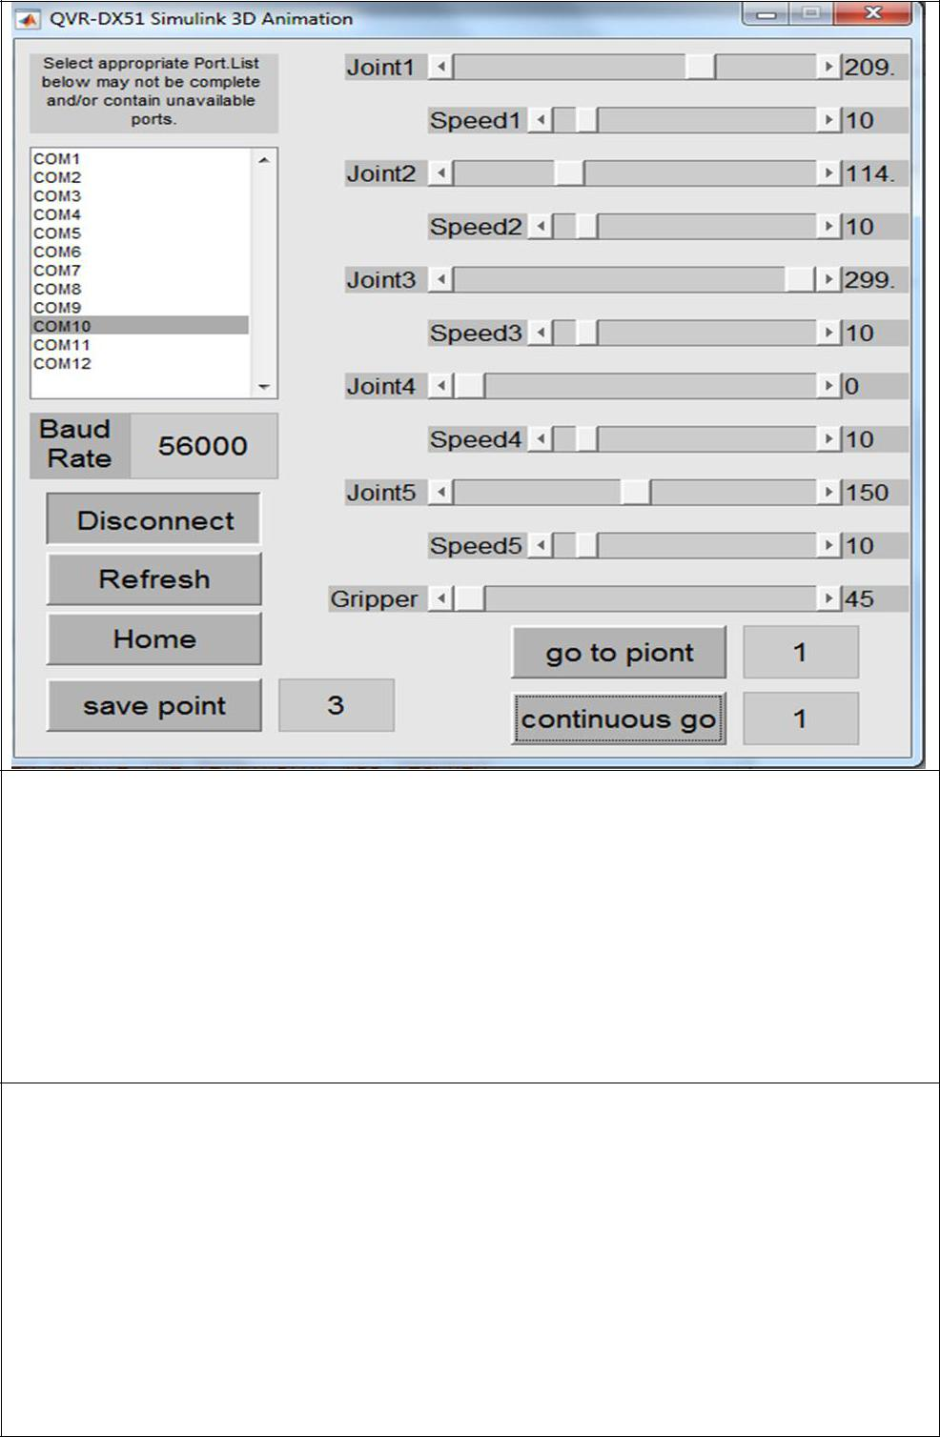

contact person:

Email:**as1.support@Qeshmvoltage.com**

Tell:**00982166733040**

Address**:** **Unit 10 , No.14 , Karimi Alley , Lalezarno**

**St, Enqelab Ave ,Tehran.Iran**

Company contact**:**

Website: [www.Qeshmvoltage.com](http://www.qeshmvoltage.com/)

Email: [info@Qeshmvoltage.com](mailto:info@Qeshmvoltage.com)

Tell :**00982166733040**

Fax:**00982166760281**

Address**:Unit 10 , No.14 , Karimi Alley , Lalezarno**

**St, Enqelab Ave ,Tehran.Iran**

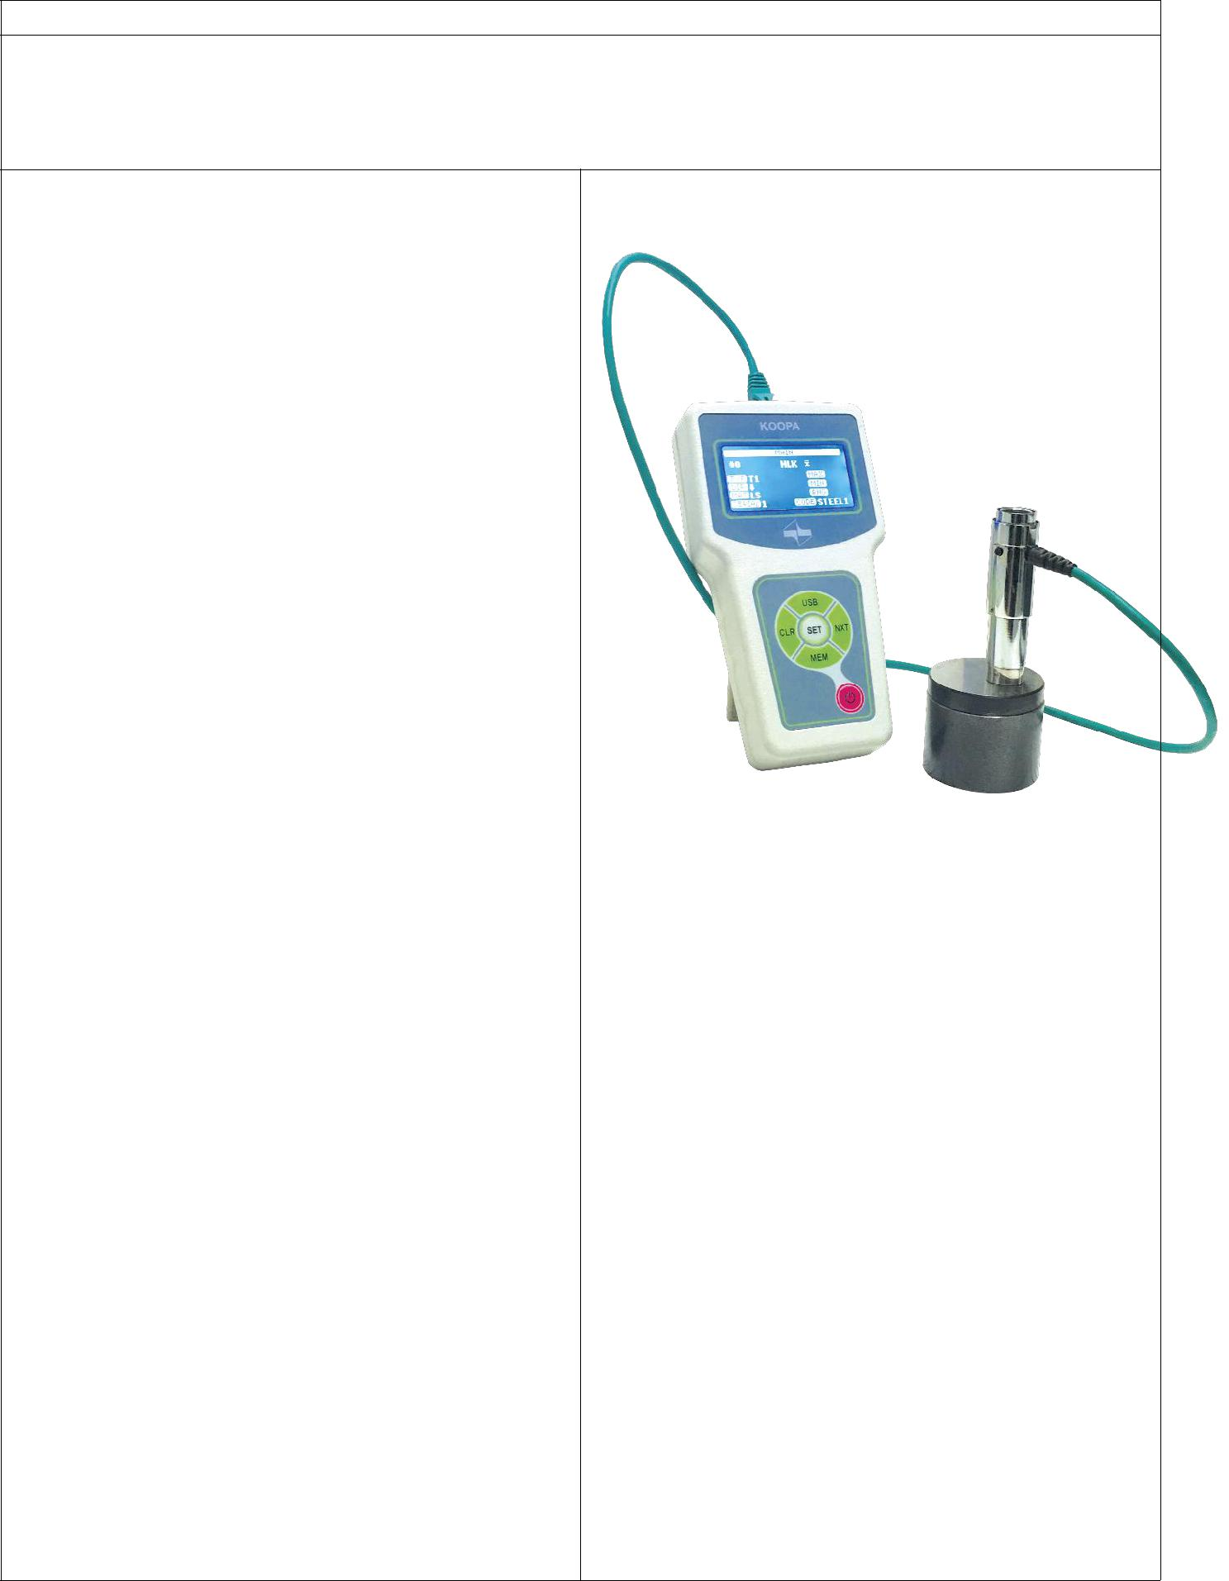

Company name:KOOPA PAZHOOHESH

Brand: KOOPA

|  |  |
| --- | --- |
| Product Specifications: | Product photo: |
| • Auto-reload impact device mechanism | **Portable Hardness Tester D06** |

* One-hand test experience
* Software user calibration
* High accuracy in magnetic-radiated environments
* 3000 tests with fully-charged battery
* Plug and play impact device D
* Auto power-off
* USB port
* 1500 built-in memory
* Same indentation energy in all directions
* Hardness testing of 8 widely-used materials, i.e., LS, HS, GG, 3G, AL, BS, BG, and CU
* Automatic conversion to Brinell, Vickers, Rockwell, Superficial Rockwell, Shore, and tensile strength
* Designed based on ISO 16859 and ASTM A956 standards
* Hardness testing conversion using DIN 50150 and ASTM E140 standards
* Automatic statistical calculation such as maximum, average, minimum, and range
* Auto angle compensation function
* Auto-reload impact device mechanism
* One-hand test experience
* Software user calibration
* High accuracy in electromagnetic-radiated environments
* 1500 memory for data storage
* Data transfer
* Hardness testing in all directions
* Same impact energy in all directions
* Hardness testing on flat, concave, and convex surfaces